environmental SCIENTIST journal: Learning Resource Notes
The purpose of these educational resource notes is to provide a format for informal, seminar-style discussions of the topics explored in the latest edition of the journal of the Institution of Environmental Sciences.

Through discussion of the ideas and issues presented within the journal, they aim to supplement and enhance students’ knowledge and understanding of a broad range of environmental science issues and provide insights into the professional concerns of practising environmental scientists.

Articles in focus
The below articles have been selected as particularly relevant for in-depth discussion, allowing for wider debate of the key elements of the article topic. Some specific questions you may wish to consider when reading and discussing these articles are outlined.

Learning outcomes | - Understand the main concepts and challenges discussed in the edition  - Describe the conclusions reached by authors, and identify their relevance to the environmental science sector  - Critically reflect on the ideas presented
Format | - Articles of particular interest are to be selected and shared with the group to read ahead of the discussion. Suggestions of focus articles are described below.  - Small group discussions of articles that closely relate to programme content to supplement learning.  - Discussions can be led by participants or the tutor, using the ‘articles in focus’ resource to prompt debate and aid the conversation.  - The suggested discussion points and questions provided in this pack for selected articles can be used as a starting point to guide the discussion.  - Students can be encouraged to choose to discuss any of the other articles within the issue.

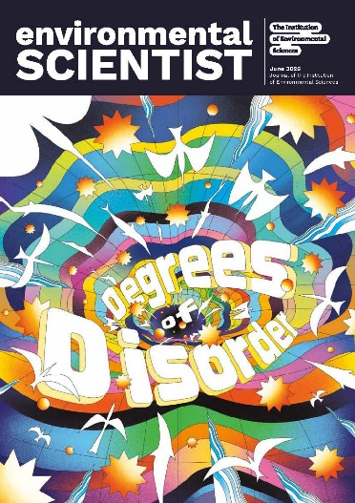
environmental SCIENTIST
Degrees of Disorder: Climate Tipping Points
Vol 36, issue 2
https://www.the-ies.org/resources/environmental-scientist-climate-tipping-points
Topic overview | By now, most of us will recognise the concept of tipping points in the context of climate change: a term popularised by climate scientist Tim Lenton and others in 2008. Tipping points articulate how once predictable earth systems – climates, weather, currents, and patterns – can reach a threshold, then permanently topple into a state of disorder.  Through the lens of tipping points, the future of our planet seems perilous: there may be massive upheavals in our boreal forests, sea ice, ocean currents, coral reefs and more, all of which threaten biodiversity, food security, and peace. However, as some of our authors in this issue explain, tipping points also offer the perfect framework for delivering positive changes: in renewable energy, social equity, and sustainable governance, for example.  With a wealth of world-leading scientists contributing to this edition, the June 2026 issue of environmental SCIENTIST, ‘Degrees of Disorder: Climate Tipping Points’, unpacks the status of key earth systems tipping points and how they are interconnected. The articles also consider the human dimension of tipping points: who is already affected, how positive tipping points can deliver change for communities, and how policy can shape adaptation and national security risk management. As Tim Lenton writes in his foreword to this edition, by focusing on the positive changes we can make and influencing others, we may be able to persuade those in charge to “change course”.
Articles in focus
‘Over the edge: a climate tipping points primer’  (David Armstrong McKay, p. 12) | Article overview: This author considers the scope and scale of earth systems climate tipping points, outlining how they intersect and interact with each other.
- Looking at Figure 1, describe how this visual aid shows how a climate tipping point can be reached.
- Explain the current status of the melting of the Greenland ice sheet, and how this could change in the future.
- Looking at Figures 4 and 5, choose one tipping point, and highlight the effects it may have (e.g. stabilising, destabilising) on other tipping points.
‘Adapting to the inevitable: who bears the burden when tipping points are crossed?’  (Sarah Redicker, p. 46) | Article overview: In this article, the author focuses on the uneven distribution of the consequences of breached tipping points, advocating for better governance and adaptation to climate impacts.
- Describe the groups of people or communities most at risk from extreme heat, and explain why this is the case.
- Discuss the barriers that have led to the “governance gap” in funding for climate adaptation in developing countries.
- How has the USA’s withdrawal from the Paris Agreement impacted the funding for climate adaptation?
‘The Atlantic Meridional Overturning Circulation at a tipping point: evidence and global consequences’  (Nicole Laureanti et al., p. 62) | Article overview: This article considers changes in the Atlantic Meridional Overturning Circulation (AMOC), and what these might mean for the future of Europe (and the rest of the world).
- Describe how the AMOC works, with reference to Figure 1, and explain its role in maintaining a specific climate in continental Europe.
- Explain one of the main impacts of an AMOC slowdown or shutdown.
- What is the projected future trajectory of the AMOC? How have scientists come to this conclusion?

