environmental SCIENTIST journal: Learning Resource Notes
The purpose of these educational resource notes is to provide a format for informal, seminar-style discussions of the topics explored in the latest edition of the journal of the Institution of Environmental Sciences.

Through discussion of the ideas and issues presented within the journal, they aim to supplement and enhance students’ knowledge and understanding of a broad range of environmental science issues and provide insights into the professional concerns of practising environmental scientists.

Articles in focus
The below articles have been selected as particularly relevant for in-depth discussion, allowing for wider debate of the key elements of the article topic. Some specific questions you may wish to consider when reading and discussing these articles are outlined.

Learning outcomes | - Understand the main concepts and challenges discussed in the edition  - Describe the conclusions reached by authors, and identify their relevance to the environmental science sector  - Critically reflect on the ideas presented
Format | - Articles of particular interest are to be selected and shared with the group to read ahead of the discussion. Suggestions of focus articles are described below.  - Small group discussions of articles that closely relate to programme content to supplement learning.  - Discussions can be led by participants or the tutor, using the ‘articles in focus’ resource to prompt debate and aid the conversation.  - The suggested discussion points and questions provided in this pack for selected articles can be used as a starting point to guide the discussion.  - Students can be encouraged to choose to discuss any of the other articles within the issue.

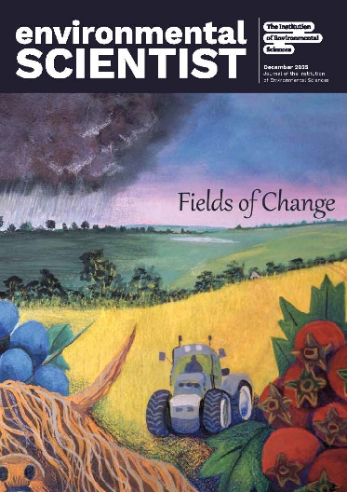
environmental SCIENTIST
Fields of Change
Vol 35, issue 4
https://www.the-ies.org/resources/fields-change
Topic overview | This timely edition of environmental SCIENTIST considers the interlinked, complex, crucial systems of agriculture and food production. It examines the potential for resilience, innovation, and transformation of our agricultural and food practices and systems, in the context of mounting pressures such as extreme weather, changing crop pathologies, an increasing global population, and pollinator decline.  Systems approaches to emerging challenges in our environment are becoming ever more vital, and therefore this journal takes a multi-disciplinary approach in investigating how agriculture is responding to challenges like green energy and water use, pesticides and weed control, and crop adaptation to changing climates.  Through articles in this issue, authors respond to questions over how policy, technology, and behavioural change can shape the future of farming and our food systems, and whether we can adapt our practices in time to achieve a sustainable relationship with farming and food production.
Articles in focus
‘The role of digital technology in delivering  agricultural sustainability’  (Kit Franklin, p. 22) | Article overview: This article explores how technology can enable a better farming future, through the use of new tools, robotics, and monitoring technologies.
- Identify 2 key characteristics of a precision farming approach as outlined by the author.
- Discuss the advantages of using UAVs (drones) over satellites for aerial monitoring of crops.
- Analyse the possible environmental benefits of the use of autonomous technologies in agriculture.
‘Developing climate-resilient vegetable varieties’  (Ashley Garrison, Lauren Chappell, Rosemary Collier,  Andrew Beacham and Jim Monaghan, p. 36) | Article overview: This article discusses the VEGIN Network, and the headway it is making in developing resistant crop varieties for resilience against climate change, heat, and flooding.
- Describe the “pre-breeding” process that helps determine stress-resilient traits within crop varieties.
- What adaptations do ancestral crop varieties offer, in contrast to commercial varieties, that might make them more resilient to climate change conditions in the UK?
- Explain the difference between abiotic and biotic stress conditions, and give an example of each.
‘Farming at the sweet spot for nature and food’  (Vicki Hird, p. 56) | Article overview: In this opinion article, the author considers the complex interplay of biodiversity and farming, and how a balance can be struck between protecting wildlife and producing food.
- List some of the challenges that farmers today face, as described by the author.
- What are some of the services that biodiversity provides for farming systems?
- Discuss some solutions to disruptions in the nutrient cycle caused by intense agriculture.

