environmental SCIENTIST journal: Learning Resource Notes
The purpose of these educational resource notes is to provide a format for informal, seminar-style discussions of the topics explored in the latest edition of the journal of the Institution of Environmental Sciences.

Through discussion of the ideas and issues presented within the journal, they aim to supplement and enhance students’ knowledge and understanding of a broad range of environmental science issues and provide insights into the professional concerns of practising environmental scientists.

Articles in focus
The below articles have been selected as particularly relevant for in-depth discussion, allowing for wider debate of the key elements of the article topic. Some specific questions you may wish to consider when reading and discussing these articles are outlined.

Learning outcomes | - Understand the main concepts and challenges discussed in the edition  - Describe the conclusions reached by authors, and identify their relevance to the environmental science sector  - Critically reflect on the ideas presented
Format | - Articles of particular interest are to be selected and shared with the group to read ahead of the discussion. Suggestions of focus articles are described below.  - Small group discussions of articles that closely relate to programme content to supplement learning.  - Discussions can be led by participants or the tutor, using the ‘articles in focus’ resource to prompt debate and aid the conversation.  - The suggested discussion points and questions provided in this pack for selected articles can be used as a starting point to guide the discussion.  - Students can be encouraged to choose to discuss any of the other articles within the issue.

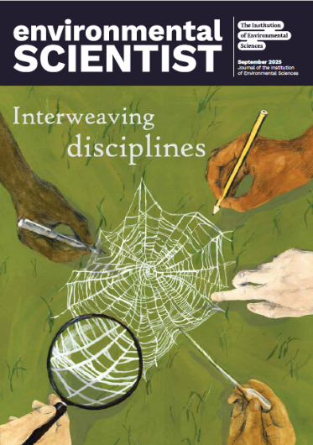
environmental SCIENTIST
Interweaving disciplines
Vol 35, issue 3
https://www.the-ies.org/resources/interweaving-disciplines

Topic overview | This unique edition of environmental SCIENTIST explores an approach that the IES has long championed in the sector: interdisciplinarity. Defined here as a way of working across and beyond traditional disciplinary boundaries, interdisciplinarity is fundamental to environmental science: a field that is home to a broad range of topics, concepts, and approaches to research and practice.  It could therefore be argued that environmental science is the natural habitat of interdisciplinary working. A less siloed approach to environmental work has gained traction over the last decade, and interdisciplinarity is now often held up as the gold standard of new research and working practices in environmental science. Professionals are encouraged to think and work with interdisciplinarity in mind: but how does this take shape when creating new research projects, new interdisciplinary teams, or engaging new audiences? Does the buzzword of interdisciplinarity bring with it adequate funding, support, and impetus for systemic change: enough to allow truly interdisciplinary work to take place, and break new ground?  This issue of environmental SCIENTIST considers the answers to these questions by showcasing success stories of the creation of new interdisciplinary communities, the formation of interdisciplinary Higher Education (HE) curricula for the next generation of environmental scientists, and considering how environmental professionals can follow their own game-changing interdisciplinary career paths.
Articles in focus
‘Interdisciplinary research: more than just a good idea’  (Jo Patterson, p. 20) | Article overview: This article explores how interdisciplinary research can be used to create positive real-life solutions and benefits for the environment and society
- Why are insights from multiple disciplines important when responding to modern environmental challenges?
- At what stage of a project should interdisciplinarity be considered, and why?
- List 3 challenges that can be encountered when working on multidisciplinary or interdisciplinary research projects.
‘Collaborative land and water management through the Catchment Based Approach’  (Rob Collins, p. 60) | Article overview: This article uses the Catchment Based Approach – a way of managing river catchments and ecosystems – as a case study demonstrating the benefits of effective collaboration across the public, private and NGO sectors
- Discuss how the Catchment Based Approach (CaBA) could be viewed as a fundamentally interdisciplinarity approach to river catchment management.
- How do partnership organisations agree priorities for action in the CaBA approach?
- Highlight two differences and two similarities between the environmental concerns of rural vs urban river catchments.
‘Transformative change: how can meaningful trans-disciplinary approaches accelerate housing decarbonisation?’ (Louse King, p. 78) | Article overview: In this article, the author explores how the transformation of the UK’s existing housing stock can be improved through interdisciplinary thinking and working.
- Identify two reasons why the UK’s housing retrofit has not been delivered at the pace and scale needed to reach Net Zero.
- Explain why national policy on housing retrofit should take into account the differences between different local areas.
- Discuss the connections between environmental and social justice in retrofitting the UK housing stock.

