environmental SCIENTIST journal: learning resource notes
The purpose of these educational resource notes is to provide a format for informal, seminar-style discussions of the topics explored in the latest edition of the journal of the Institution of Environmental Sciences.

Through discussion of the ideas and issues presented within the journal, they aim to supplement and enhance students’ knowledge and understanding of a broad range of environmental science issues and provide insights into the professional concerns of practising environmental scientists.

Articles in focus
The below articles have been selected as particularly relevant for in-depth discussion, allowing for wider debate of the key elements of the article topic. Some specific questions you may wish to consider when reading and discussing these articles are outlined.

Learning outcomes | - Understand the main ideas discussed in the publication  - Describe the main conclusions and their relevance to the environmental science sector  - Critically reflect on the main concepts discussed
Format | - Articles of particular interest are to be selected and shared with the group to read ahead of the discussion. Suggestions of focus articles are attached here  - Small group discussions of articles that closely relate to programme content to supplement learning  - Discussions can be led by participants or the tutor, using the ‘articles in focus’ resource to prompt debate and aid the conversation  - The suggested discussion points and questions provided in this pack for selected articles can be used as a starting point to guide the discussion  - Students can be encouraged to choose to discuss any of the other articles within the issue

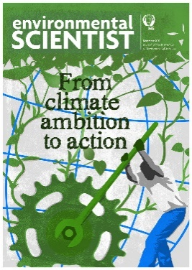
environmental SCIENTIST
From climate ambition to action
Vol 30, Issue 4
https://www.the-ies.org/resources/climate-ambition-action-1

Topic overview | COP26 presented a potentially pivotal moment in the fight against climate change – bringing together global leaders to negotiate the new Glasgow Climate Pact. This edition examines the achievements and disappointments of the conference, the benefits of natural climate solutions, the powers and influence of local government, the critical role of the ocean in tackling climate change, and many more topics.
Articles in focus
Circular economy  practice on a  small island  Kripa Dwarakanath, Daniella-Louise Bourne and Kirsty Platt (p.24) | Article overview: This article explores a circular approach to waste  management on Guam.
- Why is the implementation of circular economy solutions for waste management important on Guam, and what makes it a good location for testing circular economy principles in practice?
- What do you think are the key elements needed for successful outcomes and why are each important?
- What do you think the challenges are to applying circular economy principles elsewhere, particularly on a larger scale?
Mobilising  private capital  for nature-based  solutions  Raphaëlle Vallet, David Viner,  Adrian Barnes, Robin Grenfell  and Hannah Whyte (p.50) | Article overview: This article outlines what is needed to enable private financial  institutions to invest in nature.
- Why is private capital important in addressing the climate and biodiversity crises?
- The article describes five challenges to accelerating private funding for nature-based solutions (NBS). How do you think some of these challenges could be best addressed and overcome?
- Consider some NBS initiatives you are aware of; do you know how these are financed? Are these projects funded by private or public sources?
Local authorities  and climate action  Adam Williams (p.62) | Article overview: This article examines the powers and influence of local government.
- Describe the role and influence of local authorities in reducing greenhouse gas emissions.
- Of the suggested actions for local authorities to consider to tackle emissions, outlined on page 65, which do you think might present the best opportunities? What do you think the challenges might be to their implementation?
- What do you think might assist local authorities to act to help achieve net-zero targets?

