environmental SCIENTIST journal: learning resource notes
The purpose of these educational resource is to provide a format for informal, seminar-style discussions of the topics explored in the latest edition of the journal of the Institution of Environmental Sciences.

Through discussion of the ideas and issues presented within the journal, they aim to supplement and enhance students’ knowledge and understanding of a broad range of environmental science issues and provide insights into the professional concerns of practising environmental scientists.

Articles in focus
The below articles have been selected as particularly relevant for in-depth discussion, allowing for wider debate of the key elements of the article topic. Some specific questions you may wish to consider when reading and discussing these articles are outlined.

Learning outcomes | - Understand the main ideas discussed in the publication  - Describe the main conclusions and their relevance to the environmental science sector  - Critically reflect on the main concepts discussed
Format | - Articles of particular interest are to be selected and shared with the group to read ahead of the discussion. Suggestions of focus articles are attached here  - Small group discussions of articles that closely relate to programme content to supplement learning  - Discussions can be led by participants or the tutor, using the ‘articles in focus’ resource to prompt debate and aid the conversation  - The suggested discussion points and questions provided in this pack for selected articles can be used as a starting point to guide the discussion  - Students can be encouraged to choose to discuss any of the other articles within the issue
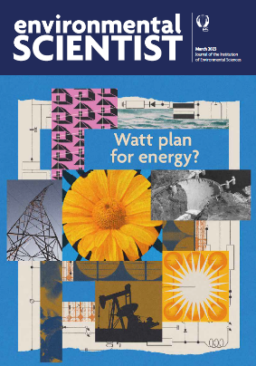
environmental SCIENTIST
Watt plan for energy?
Vol 33, Issue 1
https://www.the-ies.org/resources/watt-plan-energy

Topic overview | - The continuing energy crisis, in the midst of an ongoing fight against climate change and movement towards renewable power, has brought the importance of energy systems into sharp relief. As scientists and the public grapple with how to transform our dependent relationship with energy, many complex and competing factors must be navigated, from public opinion and social wellbeing to economic development and net zero commitments. In this edition of environmental SCIENTIST, the IES brings together key voices from multiple academic and professional fields to examine both the progress made and the challenges yet to overcome.
Articles in focus
Hydropower: the good the bad and the ugly  Mark Everard (p.74) | Article overview: examines the benefits and repercussions of harnessing water for power.
- Considering the 17 UN Sustainable Development goals, to what extent do hydroelectric dams violate one or more of these goals?
- The author recommends looking to alternative energy sources including wind and solar - with far fewer damaging repercussions for the atmosphere and water cycle - to form the backbone of the energy transition. Can you consider any consequences on ecosystem services (local or global) resulting from these energy sources?
- Consider the geopolitical (or hydro-political) issues caused by upstream damming of a large transboundary river. It may be useful to frame this using a case study example.

Creating local energy in the Royal Borough of Kensington and Chelsea  Caitlin Mackesy Davies (p.60) | Article overview: This article explains how Repowering London - community energy project - is helping one London council create a low-carbon borough.
- Who should bear responsibility for creating low-carbon communities in the UK? Discuss
- Aside from empowerment and engagement, name three tangible benefits of community energy for its users
- The article talks about ‘creating a green talent pipeline’. How could the environmental sector become more attractive to prospective professionals?
Star power: the potential of fusion energy  Mark Shannon (p.34) | Article overview: This article delves into the world of fusion physics to set out the case for a new and promising form of energy.
- Why should or should not scientists be focusing on fusion energy as the answer to a clean energy future? Name one payoff or risk that might occur from doing so.
- The article is optimistic about the capabilities of fusion energy. Can you think of any barriers to its deployment?
- Based on the other articles in the edition, what might be our best alternatives to nuclear fusion energy?

