environmental SCIENTIST journal: Learning Resource Notes
The purpose of these educational resource notes is to provide a format for informal, seminar-style discussions of the topics explored in the latest edition of the journal of the Institution of Environmental Sciences.

Through discussion of the ideas and issues presented within the journal, they aim to supplement and enhance students’ knowledge and understanding of a broad range of environmental science issues and provide insights into the professional concerns of practising environmental scientists.

Articles in focus
The below articles have been selected as particularly relevant for in-depth discussion, allowing for wider debate of the key elements of the article topic. Some specific questions you may wish to consider when reading and discussing these articles are outlined.

Learning outcomes | - Understand the main ideas discussed in the publication  - Describe the main conclusions and their relevance to the environmental science sector  - Critically reflect on the main concepts discussed
Format | - Articles of particular interest are to be selected and shared with the group to read ahead of the discussion. Suggestions of focus articles are attached here  - Small group discussions of articles that closely relate to programme content to supplement learning  - Discussions can be led by participants or the tutor, using the ‘articles in focus’ resource to prompt debate and aid the conversation  - The suggested discussion points and questions provided in this pack for selected articles can be used as a starting point to guide the discussion  - Students can be encouraged to choose to discuss any of the other articles within the issue

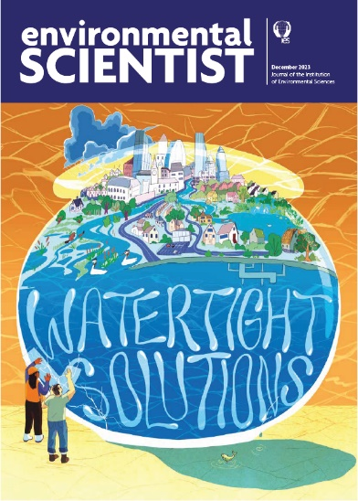
environmental SCIENTIST
Watertight Solutions
Vol 32, issue 4
https://www.the-ies.org/resources/watertight-solutions

Topic overview | The water crisis is now a familiar feature in the UK media: from sewage discharges released into our rivers and seas, to plastic pollution damaging our wastewater systems, and droughts and floods becoming an increasingly frequent concern as our climate changes.  However, amongst the growing pressures our water infrastructure faces, there are innovative governance, technological, and behavioural solutions emerging from experts and professionals across the water sector. Contributors to this issue of environmental SCIENTIST cover topics that range from wastewater to citizen science and pollution, and they address the crucial ways we can adapt our understanding and management of water in the UK, to respond to multiple environmental and anthropogenic challenges.
Articles in focus
Urban drainage in the UK: a water industry in crisis  Richard Ashley & Brian Smith (p. 22) | Article overview: This article considers the most pressing issues faced by the UK’s wastewater infrastructure and evaluates a range of solutions for addressing these challenges to help stabilise and future-proof our sewage systems.
- Describe how the combined sewer overflows (CSOs) were originally introduced, and explain why they were necessary.
- Identify three pressures on the UK’s sewerage systems that are likely to intensify or worsen over time.
- Evaluate the barriers to a UK-wide adoption of successful wastewater management techniques that have been implemented elsewhere. Has Brexit impacted on the UK’s approach to addressing problems in our wastewater systems? If so, how?
Chemical pollution of our freshwaters  Dr Rob Collins, Emma Adler, Dr Josh Jones & Anneka France (p. 50) | Article overview: This article surveys the numerous ways in which the UK’s freshwater ponds, rivers, and lakes are becoming polluted by the release of chemicals from human activities, and highlight ways to prevent further chemical pollution and mitigate existing problems.
- Explain the cycle through which harmful chemicals accumulate in higher-order mammals from our freshwater systems.
- How can chemicals polluting freshwater systems impact on human health?
- The authors in this article identify an issue with the current chemical legislation when assessing risk of hazardous substances. What is this problem, and what solutions are proposed?
- Compare the environmental impacts of each chemical group discussed in the article. Which group is the most harmful, in your view, and why?

Unlocking water supply constraints on growth  Daniel Johns (p. 58) | Article overview: In this article, the author investigates how improved water resource planning for new developments can benefit society and the environment, with a closer look at the East of England region as an example of where water resource management strategies are particularly important.
- Identify three plans being put in place to future-proof the East of England’s water resources.
- Describe some of the ways in which water scarcity has impacted policy ambitions to improve housing, and boost agriculture and energy production, in the East of England.
- Analyse the solutions the author advocates for to address the scarcity crisis in the latter half of the article. Evaluate how these solutions are interlinked, and identify some of the benefits these solutions will carry for different stakeholders (e.g. consumers, industry, and agriculture).

